A quick note before leaving for Bogoro, DR Congo,
Success is not always easy to measure. The health of a child is dependent on multiple factors; safe, clean drinking water, nutritious meals, use of mosquito nets, understanding the necessity of personal hygiene, and receiving timely and adequate medical care. One factor we know for sure; unsafe water is the leading cause of illness and death in the areas we serve. So it stands to reason that if unsafe water is the leading cause of illness and death then providing safe water negates many of the illnesses and complications they encounter.
Two years ago in Uganda, through your partnership, we repaired a well at the school and drilled a well at the farm. The two deep wells provide safe water for many people. The well at the school is open for public use. The well at the farm provides safe water for the orphans, widows and other families in the area. We are ready to drill for safe water in Bogoro, DR Congo.
Once again, through your partnership, we can impact the lives of 100s of orphans and widows and other poverty stricken families.
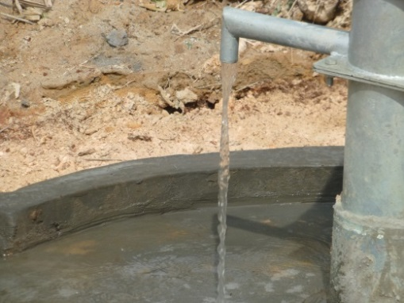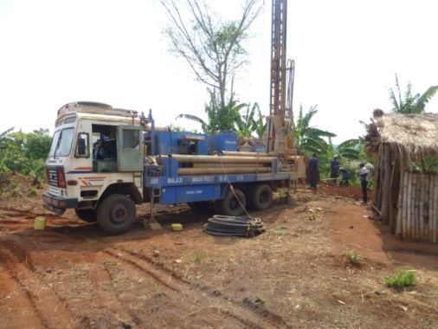
The first well to be drilled will be at the compound where the children attend school. This supply of safe water will be central to the school, the clinic and the training center. It will be available to those living within walking distance too!
Your partnership, your gift, will give to our African brothers, sisters and children, what we take for granted; Safe water.
I leave for Bogoro within two weeks. One of my goals during this trip will be to finalize the bidding process for the construction of the clinic. The Bogoro team has been diligent in going through the process of gathering information, determining the size of the clinic building, and receiving itemized bids for the rough construction.
The time in Bunia and Bogoro will allow me to visit Shalom University. Their training and expertise in community development within the Bunia/Bogoro region will likely be of great value to us. I will have the opportunity to visit with many of the new children enrolled in school. It’s exciting to see 100 new faces at school. Thanks to you, 200 orphans and impoverished children will be learning to read, to write and gain knowledge beyond their dreams.
Remember the chicken project in Bunia? We are doing the same in Uganda. The team in Uganda presented the HCCA Board of Directors with a budget request to begin the project. They will purchase 500 laying hens. We are excited to see how this project develops and grows.
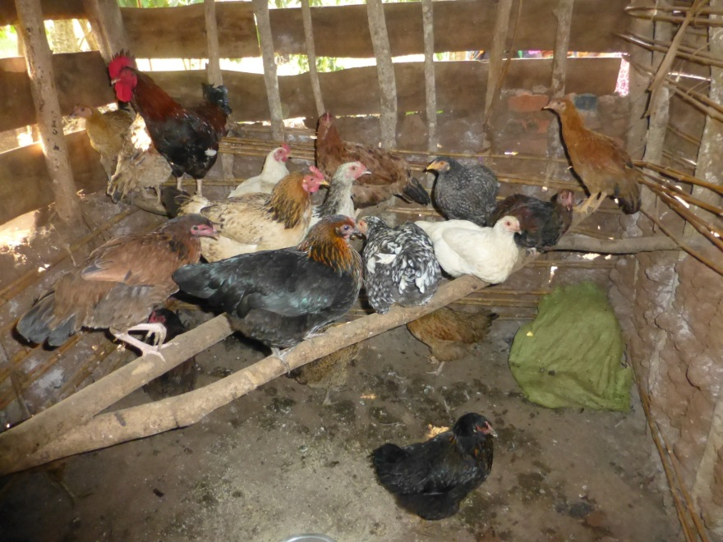
Want to partner with us?
Funding opportunities:
Purchase one chicken @ $ 3.60
Purchase 10 chickens @ $36.00
Cover monthly veterinary and medicine expenses @ $90.00
Your gift will provide them with an opportunity to move towards self-sustainability. Thank you!
In the beginning of each new ministry location we are looked upon with uncertainty. In time, trust brings smiles and hope fills the mind, body and soul. Partner with us in enriching lives as we share the love of Christ with them.

Through a very generous gift of $25,000 our Matching Funds Campaign begins in September.
Give now to take advantage of matching funds.

Blessings, Glenn

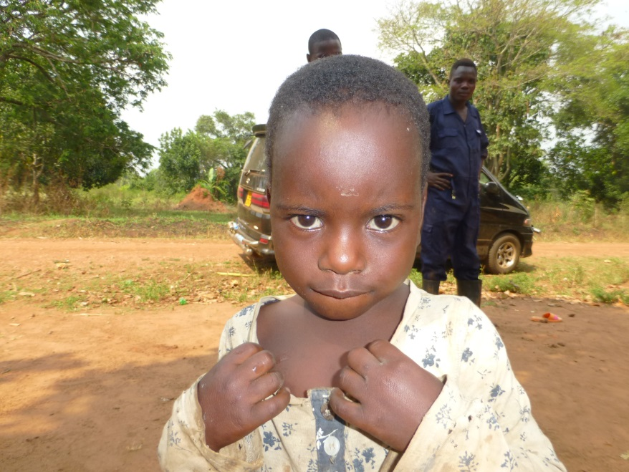
Ways to partner: Safe Water _____ School Tuition _____ Chicken Project________
Checks can be made payable to HCCA, 500 Rudy Lane, Buffalo, MN 55313
Glenn Mork, HCCA Executive Director 612-310-2395, gmork1@aol.com or hope4orphans@gmail.com
Hope Centers for Children of Africa is a 501c3 organization. Your donation is tax deductible to the fullest extent allowed by law.

